Council of Catholic Women -Archdiocese of Washington
Individual Membership Form

  Name ______________________________  Address ____________________________  City________________________________  State _______________Zip_____________  Phone______________________________  Email ______________________________  Parish______________________________  Individual Membership is only  $25.00 per year (July 1 – June 30)  Make checks payable to CCW-ADW  Send to Elizabeth Mariani, Treasurer  15008 Sunflower Ct  Rockville MD 20853  Our website is:  https://www.councilofcatholicwomen-adw.com/ | 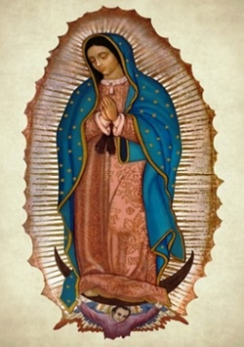  Join us and respond to the needs  of the Church and society  through spirituality,  leadership, and service  Membership Has Its Privileges  Putting faith into action by:  - Have your voices heard on the National level via the Province Director  - Discuss issues that affect women in the Church today.  - Gain access to NCCW resources (i.e., leadership, spirituality, service, and education) via the Province Director  - Vote in board elections.  - Vote on suggested events to be offered.  - Publicize your events in our monthly newsletter to over 500+people.  Membership Contact  Anita Coleman, Chair  ArchdioceseCCW@gmail.com

