Council of Catholic Women- Archdiocese of Washington
Celebrates National Black Catholic History Month 2024
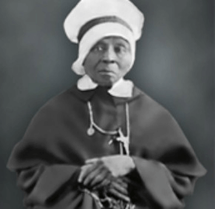
Tea and Reflection
Sunday, November 24, 2024, 3:00 PM EST
Doors Open at 2:45 PM
Janice Curtis Greene, an accomplished storyteller, author, and American Griot, will bring to life the story of Mother Mary Lange and the founding of the Oblate Sisters of Providence in her first-person interpretation of the life of Mother Mary Lange.
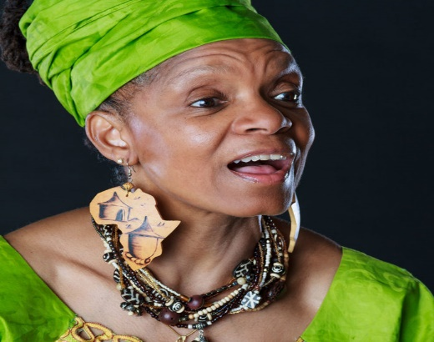
Venerable Mother Mary Lange is one of the six African Americans on the Path to sainthood.
Ms. Greene has delighted adults and student audiences throughout the United States, Brazil, Canada, Zambia, South Africa, Egypt, and on a Carnival Cruise. We are Blessed to have her!!

To Register, click the Eventbrite link below; the Zoom link will be sent to you. https://www.eventbrite.com

Questions??? Send email to: archdioceseccw@gmail.com

