Please join the
Council of Catholic Women-Archdiocese of


Washington
Virtual “Afternoon Tea” and Reflection eReflection

When: Sunday, October 20th
Time: 3:00 p.m. EST
Doors Open: 2:45 p.m. EST
Topic: Hope Stories from National Eucharistic Congress
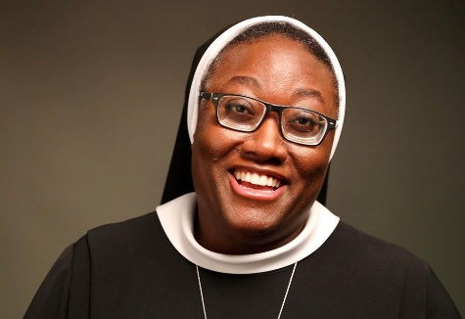
Sr. Josephine Garrett delivers a hopeful keynote that acknowledges our brokenness as humans and as a Church, pointing to Jesus as the Divine Physician who longs to meet us.
A Guided Reflection will follow.
You don’t want to miss this Free event.
To Register, click the Eventbrite link below; the Zoom link will be sent to you.

https/www.eventbrite.com/e/council-of-catholic-women-celebrating-??????

Questions? Send email to: archdioceseccw@gmail.com

